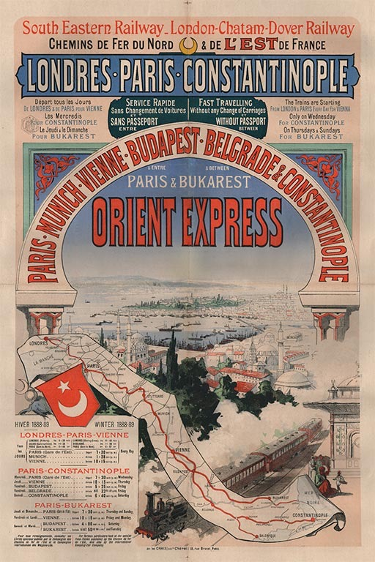
PRESS RELEASE

The Orient Express is revived on the iPad
Utrecht, The Netherlands, October 13, 2015
A new informative iPad app tells the fascinating story of the world's most famous train. The Orient Express, a luxury train service connecting Paris to Constantinople, was the figurehead of the Belle Époque. In the 20th century the Orient Express remained closely connected to European history and culture. Consequently, the app will appeal to history lovers, travel aficionados and design enthusiasts.

Rich history
The app covers over a century of Orient Express history in ten parts: from Prelude to Last train. Each part consists of concise text, richly illustrated with historical images and interactive elements:
- see hundreds of high-quality historical photos, posters and brochures
- read dozens of eyewitness accounts by known and unknown travelers
- view 360º panoramas of luxury sleeping and dining cars and grand stations
- explore interactive route maps and city plans from Paris to Istanbul

Murder and intrigue
The luxury train gained an aura of thrilling intrigue — partly thanks to books and movies such as Murder on the Orient Express. Research for this app revealed that this was not only fiction: some actual murders did take place. In 1935 a wealthy Romanian woman was robbed and pushed through the open window of the Orient Express. In 1950 the same happened to an American diplomat, probably instigated by the Soviets; he was one of the first victims of the Cold War.

Last train?
The first Orient Express left in 1883, but when did the last one run? It's a question without a definite answer. From the 1960s onwards the Orient Express gradually lost its shine. Once reaching from Paris to Istanbul, the service was truncated to Vienna only. The last remnant was discontinued in 2009. Today nostalgia trains are still picking up on the luxury image of the Orient Express.

Personal fascination
The iPad app was born out of personal fascination of its creator, Dutchman Arjan den Boer, who delved into the subject for over 10 years and started his own collection of posters, brochures and photographs. About half of the featured images come from his collection, the rest is from museums, archives, libraries and other collectors.

App Store
Orient Express History for iPad is available in the App Store for $ 5.99 / € 5.99 / £ 4.49

Press downloads and inquiries:
- press downloads including high-res images and a video with the creator: http://traiecto.com/press/
- for requesting a free installation code or other questions: info@traiecto.com

